Experiment17: Installation of Type-2 Hypervisor and VM Creation using VMware Workstation
Aim
To demonstrate virtualization by installing a Type-2 Hypervisor (VMware Workstation) and to create and configure a Virtual Machine (VM) with a Host Operating System (Windows/Linux).

Steps
- Download VMware Workstation from the official VMware website.
- Run the installer and accept the license agreement.
- Complete the installation using default settings.
- Launch VMware Workstation after installation.
- Click Create a New Virtual Machine.
- Select Typical (Recommended) and click Next.
- Choose Installer disc image file (ISO).
- Browse and select the Windows/Linux ISO file.
- Select the Guest Operating System type and version.
- Enter a name for the Virtual Machine.
- Choose the storage location for the VM.
- Configure the disk size and click Next.
- Click Customize Hardware to adjust CPU and RAM if required.
- Click Finish to create the Virtual Machine.
- Power on the VM and complete the OS installation.
- Install VMware Tools for better performance.
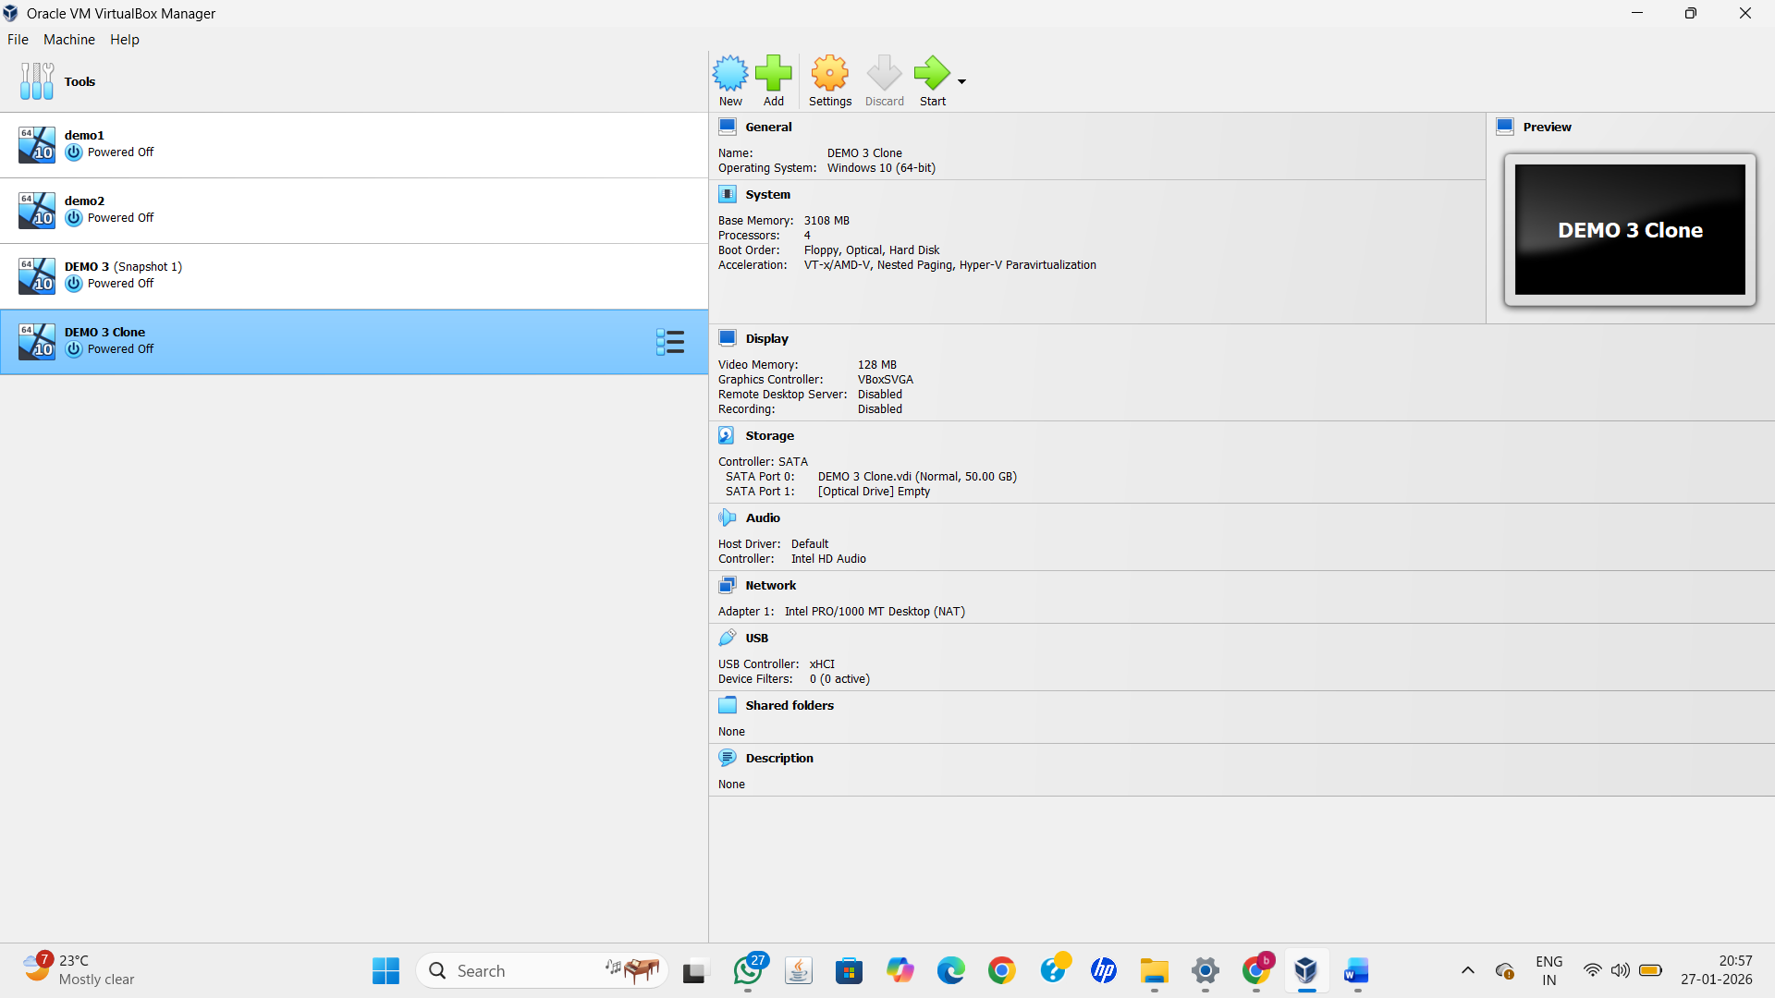

Result
VMware Workstation, a Type-2 Hypervisor, was successfully installed. A Virtual Machine with a Windows/Linux Host Operating System was created, configured, and executed successfully, demonstrating virtualization.

